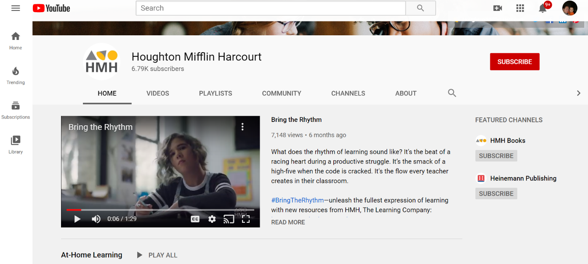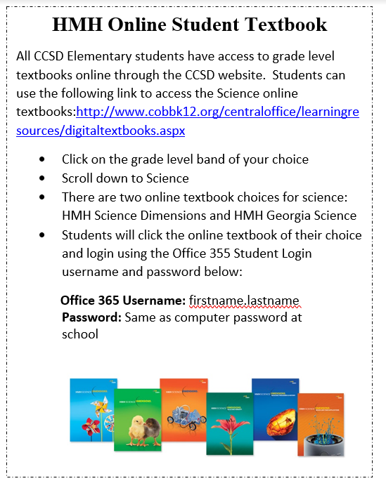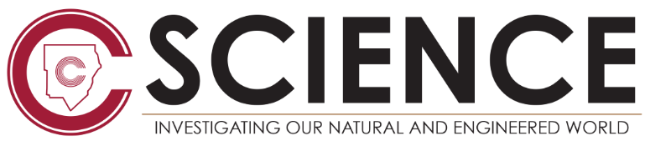

Check Out the HMH YouTube Channel for Engaging Videos

Student’s can access the HMH Online Students Textbooks using these STEPS

**HMH YouTube Channel**

[**https://www.youtube.com/user/HMHCoTV/featured**](https://www.youtube.com/user/HMHCoTV/featured)

Our online Science textbooks HMH Science Dimensions and HMH Georgia Science is a great resource for students to use while engaging in digital learning from home.

Now HMH is offering schools complete access to the HMH YouTube Channel that features videos on:

* Science Content
* Science Activities
* Teacher Professional Development series
* And Much More



**Digital Learning Resources for Elementary Students**